BusinessEurope Supplementary Response to the Public Consultation on Public Procurement
March 2025

Contents
Key Messages: 2
Introductory Remarks: Competition is lacking 3
Comparing the Drivers of the 2014 Public Procurement Reform with Current Day 4
Response to the Questionnaire 4
Section 3: Addressing strategic challenges 5
Section 4: Competition 7
Section 6: Resilience 9
Section 7: Below EU thresholds procurement 11
Section 8: Private procurement 11

Key Messages:
- We believe the public procurement framework works as-is and issues stem from ineffective implementation. Strengthening the enforcement of existing procurement laws and looking for ways to simplify and reduce administrative burdens is in our view the way forward. However, simplification should not be understood as entailing new regulations to solve the problem.

- The European public procurement market has a serious problem in the lack of competition. Enhancing data collection and monitoring to better understand market dynamics and inefficiencies is paramount. The decision to revise the framework already without gathering the proper evidence, and a clear goal, is ill-advised.

- The public procurement framework should remain procedural, detailing ‘how to buy’ not ‘what to buy. ’ There is no ‘one-size fits all’ solution and while sectoral legislation plays an important role in strategic procurement it must remain harmonised with the overall procurement frameworks to maintain legal consistency.

- For Green/Sustainability criteria we strongly encourage stronger procurement practices for GPP so that it is upscaled. Criteria need to reaffirm the link to subject matter but should feel free look at Total Cost of Ownership, or relevant environmental standards for example. Authorities need to feel confidence that they will avoid triggering legal action against their decisions when applying these criteria.

- Strategic Criteria during this geopolitical era are extremely relevant. Introducing clauses to promote European preferences need to be approached with caution as these can undermine the EU’s GPA agreement and other trade obligations. If applied poorly in a broad manner, ‘Buy European’ can negatively affect globalised companies who need to diversify their supply chain to mitigate possible supply shocks. The Net Zero Industry Act however does introduce a novel mechanism that the Commission should further assess to see if it can be applied to other very narrow critical areas.

- Regarding social criteria, we strongly agree that social dumping is an unacceptable practice. The procurement framework already has a strong base to allow for the application of social criteria. National labour conditions must always be respected, and companies cannot be forced into collective bargaining as a condition for tendering. Social clauses must be implemented in a way that ensures fair competition and is practical for companies to apply.

Introductory Remarks: Competition is Lacking

Public Procurement is undeniably important issue for the single market, a common figure given is that it accounts for 14% of EU GDP. For 2022 alone, the estimate of total general government expenditures on works, goods and services (excluding utilities & some concessions) amount to 2114.3 billion EURs leading to 14.5% of EU GPD, while the value of tenders published in TED for all directives amounts to 815.32 billion EUR, significant increase from 2021 which was 666.6 billion EUR.
The past decade since the 2014 reform, and as reflected in the 2017 procurement package, and the Court of Auditors report, prove that there are systemic issues in public procurement. Yet due to the sheer economic implications any reforms undertaken must be conducted with the utmost thoroughness and caution in alignment with Better Regulation Principles.
While speculation of a revision was ripe in Brussels in the past years, the sudden announcement to revise the procurement framework by President Von der Leyen is not entirely welcome by the Business community. This announcement creates a heavy bias on the upcoming evaluation in favour of revision and lacks substantial data to warrant this conclusion. We would have preferred that the Commission first conduct the exercise of data collection and additional studies as called for in the Council Conclusions on Public Procurement before enacting the process of evaluation and revision. As a reminder the evaluation process leading to the 2014 reform had seven additional studies conducted to assist in the impact assessment formation. Whereas this evaluation seems to only have launched three that we are aware of.
We reiterate that we do not deny the severity of issues in procurement but rather we question if a legislative reform will be sufficient and if instead efforts should be made on implementing and enforcing the existing laws. As a final note we underline that the EU public procurement framework must remain procedural, that is ‘how you buy’ rather than ‘what you buy.’
The main question of concern for us, and many stakeholders, is that of competition. It has to be acknowledged that no reform of the Directives to promote the uptake of any strategic goals will be successful if the market is non-existent. As the European Court of Auditors report states ‘There is a lack of awareness for competition as a key prerequisite for value for money procurements. Commission and member states have not made systematic use of data available to identify the root causes of limited competition in public procurement; and they took only scattered actions to reduce obstacles’ pg 47.

Comparing the Drivers of the 2014 Public Procurement Reform with Current Day

In assessing if the current framework is suitable, it is imperative that the situation pre-reform is revisited in order to establish a comparative baseline.
In 2009, EU legislation applied to 150,000 procedures involving 420 Billion EUR or 3.5% of EU GDP, while overall in 2009 the public sector spent about 19% of EU GDP on procurement across 250,000+ various government departments and public bodies.
While the cost of running procurement was 1.4% of all purchasing volume, In 2009 this was about 5.3 billion EUR. In that, business incurs the largest share of these costs at 75% and the average competition took roughly 123 person days of resources, equivalent to about 28K EUR. There seems to be no relation between costs and contract value for the vast majority of contracts. So costs are likely to be much larger as share of value for smaller contracts, when it comes to contracts around the threshold value this can lead to costs for business and governments of about 30% of contract value. (PwC pg 5)
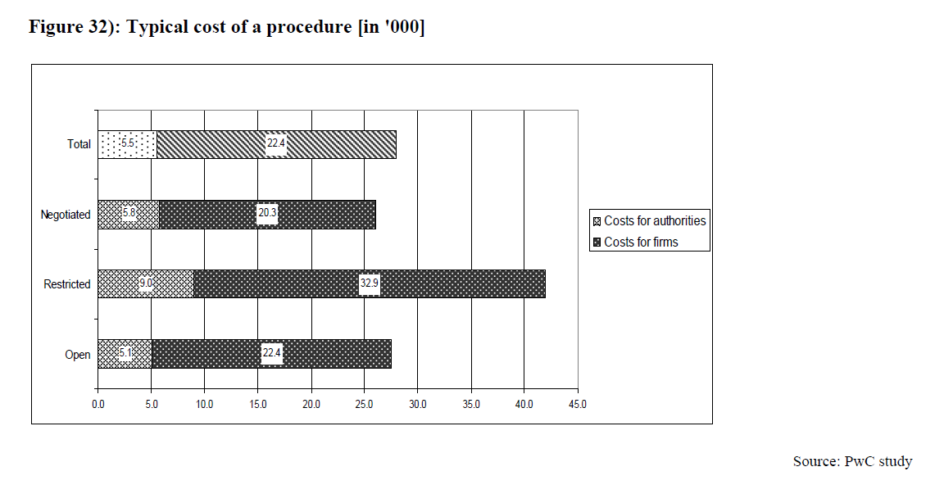

The Impact Assessment from 2011 outlined some key drivers that justified the reform at the time. Reflecting on those drivers gives the impression that not much has changed in EU procurement since then and the waring given in the IA rings truer still despite the fact the EU did take action.
‘To conclude, if no action is taken in the five above mentioned problem areas, cost inefficiency will at best stay as it is, and could even deteriorate. The fear of litigation which has lead to a tick-box approach to compliance, rather than outcome driven could further increase costs and continue the trend of legal uncertainty. ‘

Response to the Questionnaire
Below are expanded answers on select sections from the questionnaire.

Section 3: Addressing strategic challenges
Regarding strategic procurement for GPP, SRPP, and PPI the Directives give the necessary theoretical basis. It is true however that Member States still rely on lowest price as the main criteria. However the EU must be cautious against moving to a framework that dictates Contracting Authorities ‘what to buy.’ The implementation of any strategic criteria must always be linked to the subject matter. A blanket imposition of quotas/criteria without the regard to the circumstances and resources of buyers can lead to sub-optimal procurement practices such as limited competition or corruption.
A slightly worrying example of how this can lead to contradictions is that Spain is seeing an increase in the number of criteria that are already mandated for in existing law, (almost 1 in 10 criteria are made redundant this way) thus nullifying the strategic value and purpose of the inclusion of those criteria in the tender.
The 2015 study on the Strategic use of public procurement in promoting green, social and innovation policies indicated that at the time Member States were already implementing some mandatory measures at certain administrative levels.
From the demand side, contracting authorities that are regional/local authorities make up the overwhelming share of the push for strategic public procurement.

Contracting authorities, regardless of the Directive reform, see strategic procurement still as a greater risk.
In the data collected for the 2011 IA, survey data found that 37.9% of the participating contracting authorities experienced an increase in cost when stipulating for environmental requirements, while 33.2% reported costs stayed constant and only 1.7% saw no increase in cost. This can suggest strategic procurement entails a higher cost, which as addressed under the SME questions of the survey can particularly disadvantage SMEs from participating. In the instance of award criteria the authorities would have to demonstrate that a rating of the different tenders against the other criteria is being done fairly and properly and the outcome has not been distorted. What can assist in shouldering the burden of costs related to strategic procurement is the usage of a price adjustment mechanism to cover changes in energy, material or labour costs for example.
Spain again provides an interesting example of how this can look in practice: for admission criteria in Spain for 2023 of the 3,240 contracts 83.95% did not use any criteria for admitting. This is a drop from 2020 where the results were 90.36% In terms of award criteria itself, the percentage of non-use was 66.42% Award criteria seemed to prefer social criteria at 17.87% followed by environmental (5.43) and innovation (2.41) For Spain there are at least 158 different types of social criteria that can be applied which demonstrates the variety but also the high susceptibility to fragmented interpretation that can occur. Only 15 of the 158 criteria were found to be applied more than 1% of the time among 1,824 contracts.
In the political scenario of dictating ‘what to procure’ we find it will be extremely difficult to conduct negotiations across generally 4 strategic criteria at a granular level when, for example, at least 158 different kinds of social criteria can be found in one Member State.
This hesitation by authorities to utilise strategic procurement and deviate from the traditional ‘price’ only method can be explained as well by the fact the implementation of the directives translates into a fear of authorities making errors in the process and triggering legal action.
In the 2011 IA survey data showed that 25% of responding contracting authorities incurred a form of litigation cost above threshold. On average this 25% reported 8 person-days of cost dedicated to handling litigation complaints. Implying an average for all gov. authorities in EU of 2.6 in-person days per transaction or about 350.000 person days annually across Europe for managing litigation/complaints. (IA pg 110/PwC pg 80) One way to solve this is to continue focusing on the need to increase professionalisation of buyers and the tenders. Earmarking procurement damages imposed on a contracting authority for special education/skills fund could be an example of how to fund and sustain professionalisation programs.
It could be for these reasons in general strategic procurement is not a common practice. When it is used, GPP is most frequent at 14% of the sample size in the study. Social (SRPP) is at 10%, innovation at 1% whereas GPP amounted to 64.8 billion EUR, or 25%, while SRPP was at 44.7 billion, 17%, PPI at 18.4 billion, 7%

When it comes to environmental criteria and GPP, efforts should be made to properly implement the green public procurement provisions in newly adopted legislations, such as Ecodesign for Sustainable Products Regulation, Batteries Regulation and Construction Products Regulation, by establishing clear tendering criteria. Substantial benefits could be attained, in particular within the construction sector, and in general, by applying the principle of “total cost of ownership”. Where a contracting authority specifies performance or awards on the basis of environmental criteria, a “direct link” with the subject matter of the contract must always exist. Measures to create lead markets to stimulate demand for green products can also include private procurement policy, market sector commitments as well as government incentives for top performers.
For SRPP we view the current social related provisions of the public procurement directive in articles 18, 67, and 70 focused on the most economically advantageous tender including economic, innovation-related, environmental, social or employment-related considerations, combined with article 9 in the minimum wage directive, provide enough scope for public buyers to include relevant social related award criteria in public contracts.
We do not support the introduction of EU-wide ex-ante social criteria in the public procurement directive. This applies in particular to award criteria, which would favour companies with collective agreements in tender procedures. A key principle of industrial relations is founded on voluntary organisations taking part in collective bargaining when they want to do so. Legislators should stay away from this and respect the autonomy of social partners.
This means that access to public procurement should be open to all companies. Freedom of association is mentioned in art. 9 of the minimum wage directive. The future revision of the EU public procurement directive must also respect employers’ freedom of association, as defined in ILO Convention 87, article 3 and 11. Employers must not be forced in collective bargaining.
We also look forward to contributing from a social affairs perspective to the broader discussions on a price adjustment mechanism to be set in the public procurement directive.
Such a price adjustment mechanism should cover for situations where the contractor experiences higher labour costs deriving from new collective agreements obligations during the period of execution of a public contract, to make sure that these higher labour costs can be reflected and compensated for in a higher price.
Finally, a clear distinction needs to be made between public procurement and social policy objectives. A public contract sets the conditions for a contract demanded by a public buyer related to a well-defined subject matter and for a given price. Public procurement laws at EU and national level are not the right vehicle to pursue employment, skills or social policy objectives that are disconnected from the performance of public contracts.
For innovation procurement the most recent December 2024 benchmarks indicate that no area of the benchmarks used to measure innovation procurement have the EU average above 65% (solid or strong performance) Survey data from 1,926 enterprises provided by NHO our Norwegian federation member provides some additional sentiment analysis for innovation procurement. Suppliers see the CAEs as too price-focused, with this being particularly problematic in the electric and construction sector. Additionally, suppliers have the impression that the buyers have little knowledge of the market and that there is too little dialogue with the CAEs prior to the call for tenders.

Section 4: Competition
We believe the phrasing of these questions is poorly done and is too simplistic. However, It is startling to see the change in competition, the PwC study from 2011 found that competition was considerable at the time, with an average of 5.4 offers per tender, and local government markets being more competitive than at central level. (pg6) Unfortunately as we explain below this optimistic outlook has changed.
A high frequency of Single Bidding can be seen as a bad procurement practices but may be a mix of market factors and bad practices. It is too simplistic to declare the practice as A. or B. The fact is, as the ECA report shows from 2011-2021 single bidding increased from 23.5% to 41.8%. While the number of bidders has dropped from an average of 5.7 to 3.2 bidders per procedure.
Yet single bidding is legally permitted so long as the principles of transparency and non-discrimination are respected. Rather the contracting authority could face potential exposure to liability if they decide to cancel the tendering procedure on the basis of only a single bid as established by the ECJ under C-92/00 'Hospital Ingenuire' (para 55) There are numerous 'single bidding' practices that exist in the procurement framework such as the usage of the Innovation Partnership or the granting of special and exclusive rights in the utilities directive which further complicate the matter. In the course of the evaluation it must be investigated to what extent a revision of the 2014 Directives should specifically state actions regarding single bidding, or if this is a matter for implementation. Such ideas could be to replace the lowest-price criterion with a lowest cost of total ownership or second lowest price auction.
As the ECA report shows, the frequency of direct awards varies greatly across Member States from as low as 3.1% to 42.3%. In theory the practice can be legitimate, but it should not be a norm or usual practice for contracting authorities to seek this option. It is therefore a mix of bad and legitimate procurement practice depending on the circumstance and market conditions of the sector in question. The ECA report illustrates that from 2011-2021 direct awards in Financial Services dropped from 18% to 8% whereas in energy they rose from 16% to 29%, we agree with the ECA conclusion that contracting authorities seem to react to the competition conditions of the sector. Overall the rate of direct awards is too high.
Regarding the high frequency of price only awards, it is problematic to see high price-only awards but in many instances it remains the most legally sound criteria that can be used without other bidders wanting to challenge the award in court. It is undeniable that price-only has risen, the indicator flagged by the ECA is that the EU average number of bidders has dropped from 5.7 in 2011, to 3.2 in 2021 while Single Bidding increased from 23.5 in 2011 to 41.8 in 2021.
The ECA’s findings can be reinforced from the data collected by PwC in 2011. PwC found in that 1 in 5 tenders received one bid (so 25%- in line with ECA) While in 2011 most tenders received 4-6 offers. Procedure-wise this also made a difference as Open and Restricted were around 6 offers per tender, indicating these may be more conducive to competition than negotiated procedures.
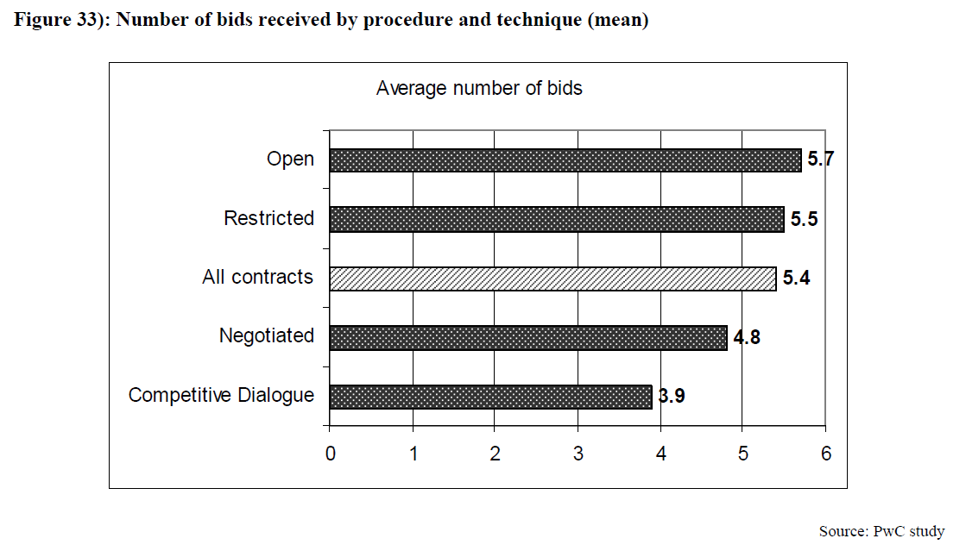
However, while Open procedure may be more conducive to competition, it would appear it could also lead to a preference for price-only. The 2011 PwC study showcased that 70% of tenders at the time used a combined EMAT criteria, while 30% were lowest price only. Price was mainly used in less complex procedures like negotiated without publication or accelerated. The more complex procedures such as restricted and negotiated used price less. While the competitive dialogue hardly used price. However in open procedure, 65% utilised price.
All this indicates is that the correlation and relationships between procedures needs to be closely evaluated and more comparative data is needed before any assertions on the solution to the problems in competition can be made. If one were to take the findings as promoting more MEAT/EMAT criteria, as it is used for 2/3 of purchases this in turn creates a significantly more expensive bidding process than just price reliance. Which means the lost money is higher, for example the typical cost of a competition in 2011 was 28K EUR. A way to avoid price only could be to encourage CAEs to factor lowest TCO instead of price. We also note the verdict from the ECJ in Case C‑424/23, which outlines the functional requirements for competition and the 'equivalence clause.'
On competition in general, from the data collected by our Swedish Federation SN, in Sweden, it emerged that in 65.2 percent of cases the winners were recurring or partially recurring winners. We strongly suggest the European Commission conduct a similar survey to complement and deepen the results of this finding. In our view 65% is too high and stifles competition.

Section 6: Resilience

Resiliency criteria has taken on new geopolitical importance over the past years and it is undeniable that the EU must take a strategic yet open perspective on the matter. Somewhat paradoxically however, when looking at third country sourcing, from the Study on cross-border penetration, less than 30% of the winning companies stated they imported goods or services from 3rd countries. The vast majority (71.8%) do not import from outside. Thus from a wholistic perspective it would appear the EU has a healthy and resilient base already occurring.
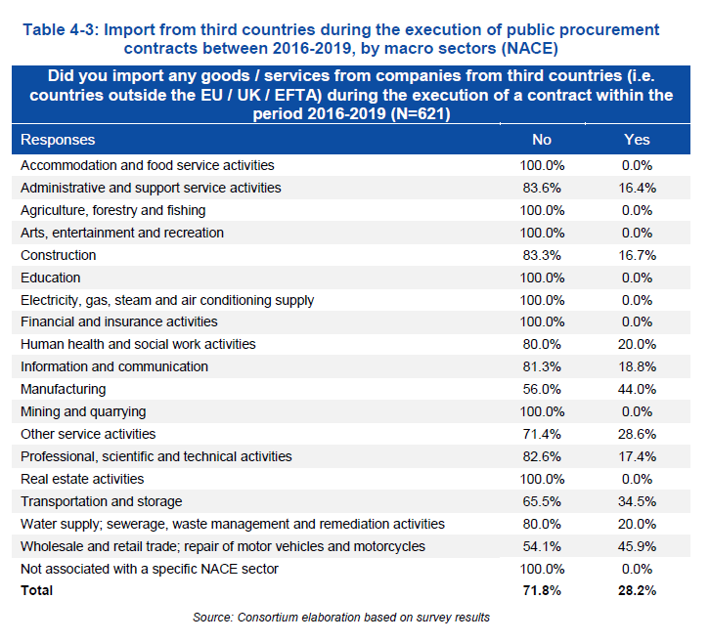
(Study on the measurement of cross-border penetration in the EU public procurement market- pg 138)
However, the majority of economic operators that only win tenders abroad seemed to import goods or services from third countries. (pg 139) From these third countries which export goods, it is the USA and China as the most frequently involved suppliers (52.9 and 50.3% respectively)
The directives set the groundwork for achieving strategic autonomy yet the idea of introducing 'Buy European' criteria must be carefully weighed and certainly any blanket justification for 'buy local' must be avoided.
However we do acknowledge that some sectors may benefit from this approach and a limited preference for European may be required given the geopolitical situation. The fact that the Directives allow for a sectoral approach as evident by the Net Zero Act is an important indicator of their suitability in theory to meeting the current challenges around dependencies. The methodology the NZIA introduces could be applied to other sectors. However sectoral legislation must always respect the main procurement framework and the EU's obligations to the GPA.
Yet considering the importance of the NZIA as a template for resiliency criteria we wonder if this section is premature as the NZIA has yet to fully be implemented (importantly the minimum requirements for sustainability) and much of the data required to assess the effectiveness of the NZIAs criteria has yet to be collected.

Section 7: Below EU thresholds procurement
Procurement under the threshold is XYZ.
The findings for 2011 indicated that in theory if the thresholds would be raised, Open procedure would be used less, as at the time 2/3rd of procedures were Open.
However with the slight increase of the thresholds, it appears that the fear that Open procedure would decrease did not occur. The ECA indicators for ‘non-open procedure’ show that the EU average was 24% whereas in 2011 it was 26.9%.
Below threshold procurement also depends on sectors, in 2011 a majority of works contracts were below the threshold, Germany had 95% below for instance.
But low value/threshold contracts pose economical issues as well. The typical procurement procedure cost in 2011 was 28k EUR. Authorities paid 5.5k per call, firms paid 3.8k per offer. The total yearly cost of all procedures was 5.6 billion EUR yearly.

Section 8: Private procurement
In 2011 procurement was seen as disproportionate with the process. The survey done at the time showed that 57% of responding firms using Open procedure found it was cheaper to sell to the private sector. 59% agreed that the private sector process is less time consuming.

Public Procurement Indicators 2022
REQUESTS from the Commission to undertake, without delay, an in-depth analysis of the existing legislative framework on public procurement (including Directives 2014/23/EU, 2014/24/EU, and 2014/25/EU) to assess whether a revision is necessary during the 2024-2029 term in light of the major commitments that the EU made in order to achieve its sustainable development objectives by 2030; INSISTING, however, that in addition to carrying out the in-depth analysis, it is essential to achieve a better understanding of the root-causes behind the decrease in competition in public procurement;- Council Conclusions on the European Court of Auditors’ Special Report No. 28/2023 Improve a fair and effective competition for EU public procurement contracts awarded for works, goods, and services (C/2024/3521)
Special Oversight Report on Strategic Procurement in 2023, The Independent Office for Procurement Regulation and Oversight (OIReScon)
Annex IV ibid.
Strategic use of public procurement in promoting green, social and innovation policies – pg 42
Results from December 2024 COM report https://research-and-innovation.ec.europa.eu/document/download/042cc514-04f9-4b2e-9827-91ff3b23883f_en?filename=ec_rtd_synthesis-report-policy-benchmarking.pdf pg 12

